Building Community through ART & CULTURE
Call for Artists

SUMMARY
Woonsocket residents have identified the need to build community within the city, providing residents and visitors with a central hub for rich cultural opportunities. The ARTech District has been identified as this central hub. The District spans from RiverFalls Restaurant to 40 S. Main Street (the Old Mulvey’s Hardware store) and includes River Island Arts Park.

NeighborWorks Blackstone River Valley (NWBRV) is providing funding to artists interested in using their talents to build community and make positive physical, economic, or social impacts within the ARTech District through art, culture, and creativity. This is something that is often called Creative Placemaking. It honors the insights of all community members, including the people most often unheard, and promotes a place where all are included and welcomed.

At NWBRV, we define an artist very broadly. Artists can include trained professionals and the self-taught. You can be an artist cooking in your kitchen, in your woodshop, through dance or performance, in the digital space, through more traditional painting and sculpture, or through many other avenues. If you have a creative idea for how to physically, economically, or socially impact and build community, we want to hear it. We also want to ensure that this idea is grounded in the Woonsocket community, and so all proposals should reflect conversations with community residents and those you aim to impact.

GRANT CATEGORIES
Grants ranging from $250-$5,000 will be provided to artists to support the following categories:
- Resident Community Building
- Youth Vision
- Community Cultural Vibrancy

All projects are expected to take place within the ARTech District (The District spans from RiverFalls Restaurant to 40 S. Main Street -the Old Mulvey’s Hardware store- and includes River Island Arts Park).

Proposals should speak to one of the categories addressing how the idea supports resident community building, highlights youth vision, or amplifies cultural vibrancy within the community. Proposals should also demonstrate how they support the Creative Placemaking values listed below.

CREATIVE PLACEMAKING VALUES
- Artists as Leaders - artists themselves have tools, skills, and talents to lead the path to change
- Racial Equity - we value equity as a whole, but in particular, racial equity to ensure that people of color and those historically marginalized are at the center of transforming their communities
- Community-Driven Collaborations - we prioritize collaborative efforts and believe that residents and communities must identify their own needs and be at the heart of community transformation efforts
- Sustainability – the impact of great projects should be felt long after the project concludes

BACKGROUND
Since 1987, NWBRV has been working with residents, businesses, neighborhood institutions, partners, and communities to enrich neighborhood life and make affordable housing opportunities available throughout Northern Rhode Island. As a community development corporation, NWBRV prioritizes asset-based development that is community-driven with broad resident involvement. Development is more than the bricks and mortar; it encompasses that which moves neighbors from strangers into community.

This Creative Placemaking initiative focuses on bringing this culture and vibrancy to NWBRV’s newest development, two historic mill buildings located within the ARTech District right at the gateway to Downtown Woonsocket. Previously a hub for the arts and technology, NWBRV seeks to reenergize this rich history.

The Kresge Foundation, through The Local Initiative Support Corporation (LISC), has generously provided funding to NWBRV for Creative Placemaking in Woonsocket. These funds will be dedicated to revitalizing the ARTech District.

THE ARTECH DISTRICT - VISUAL

Depiction of the ARTech District- ranging from 40 S. Main Street (right) to River Falls Restaurant (left) and includes River Island Arts Park (back left)
Event Space – 40 S. Main Street | Patio – 40 S. Main Street
Perfect for large events- can accommodate up to 125 people. Features screen, sound system, microphone, 11 tables, 80 chairs, 2 restrooms.  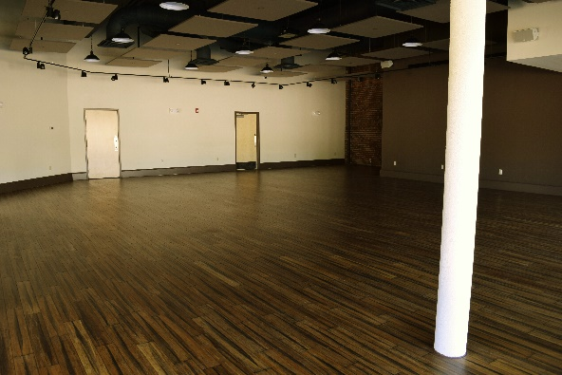 | Ideal for outdoor events and vendors. Includes access to event space restrooms and electricity.  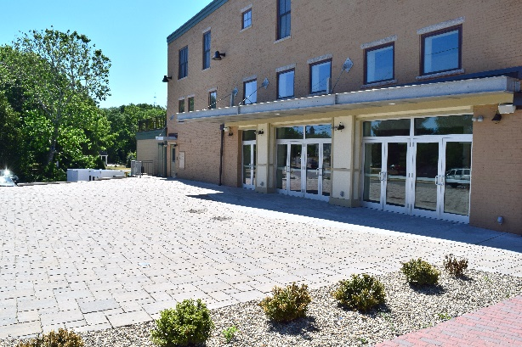
Basement – 40 S. Main Street | River Island Arts Park
This space would be ideal for smaller gatherings, classes, retail, or as a gallery space. Features its own restrooms (no tables or chairs provided).  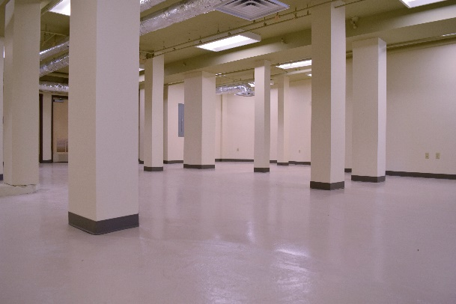 | Park full of natural beauty with green open space, a gazebo, stage, concession stand, and restrooms. REQUIRES ADDITIONAL APPROVAL FROM CITY PARKS & REC.  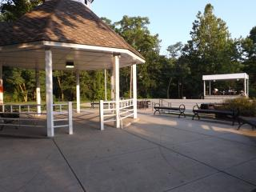

APPLICATION
Artists are encouraged to apply for funding to complete a Creative Placemaking project. Applications are due to the final day of each month until all project funds have been disseminated. Proposed projects must be completed by September 2017 and take place within the ARTech District.

Applications will be screened by a review committee for alignment with the spirit of the Call and connection to Creative Placemaking values. Applicants will be notified of proposal status by the 15th of the month following submission.

First Name: First Name Last Name: Last Name

Phone Number: (XXX) XXX-XXXX E-mail Address: Insert e-mail address

Project Title: Provide a Title for your Project

Start Date: Project Start Date End Date: Project End Date

Additional Date Details: If needed, add additional details about the dates of your project, time etc.
Provide any additional details about your selected project date/s if needed, including times, etc.

Requested Grant Value: Insert value from $250 - $5000
Please include a budget with your completed application. Can include funding for supplies, marketing, food, artist time, permits, etc. Organize budget according to category (marketing, decorating, etc.); we do not require a list of specific items. The cost of space rentals including cleaning fees and utilities for NWBRV properties do not need to be included in your application and will be funded separately. NWBRV can also provide a tablet and credit card reader for retail purposes.

Requested Space: Select the primary space for your project

Select the space that you would like to use for your proposed project: 40 S. Main Street Event Room, 40 S. Main Street Patio, 40 S. Main Street Basement, River Island Arts Park (requires additional reservation process through City Parks and Rec. department. Application can be found at http://www.woonsocketri.org/parks-recreation/pages/permits-process), Other. See page 3 for descriptions and images of available spaces

Describe “other” space if selected: What “other” space do you plan to use?

Grant Category: Select the category that best aligns with you proposal

Proposal (Answer each question in no more than one paragraph):
- Describe your project. What specifically do you plan to do? Who are the intended audiences? What is your timeline for project implementation?
Click here to enter text.

- How was this project designed with members of the local Woonsocket Community?
Click here to enter text.

- How does this project connect with your indicated grant category (Resident Community Building, Youth Vision, or Community Cultural Vibrancy)?
Click here to enter text.

- How does this project align with the Creative Placemaking values of artists as leaders, racial equity, community-drive collaborations, and sustainability?
Click here to enter text.

- Please describe your strategy for promoting this project in the Woonsocket community and surrounding area.
Click here to enter text.

- Share a bit about your background and why you want to do this project and are the right person to implement this project.
Click here to enter text.

Submit: E-mail completed application to mrego@neighborworksbrv.org
If appropriate, include images of your proposal or previous related work for the committee’s consideration
Include a detailed budget

